Exercise 2: Verifying Interactions

**Step 1:- . Created a mock object for the external API.**

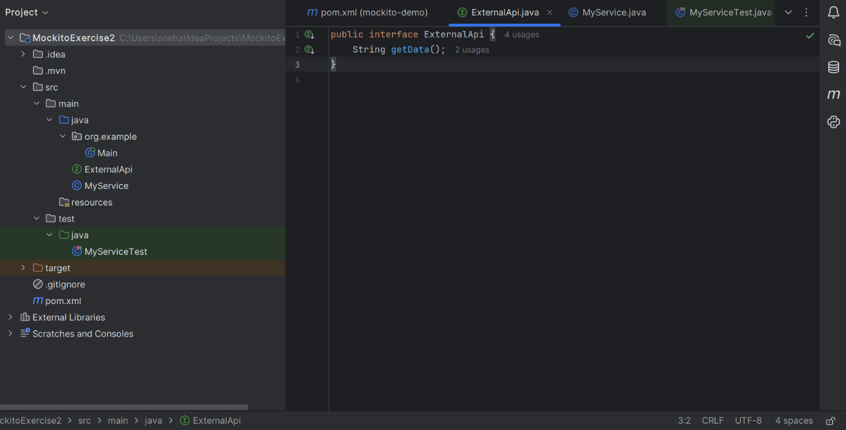

**Step 2:- Calling the method with specific arguments.**

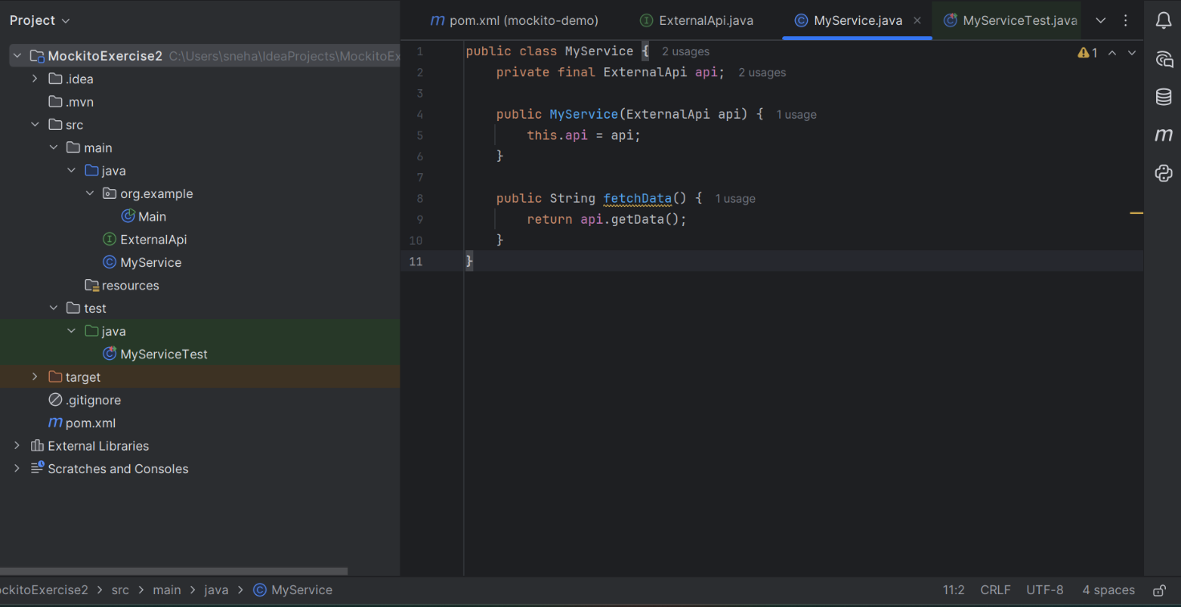

**Step 3:- Verifying the interaction.**

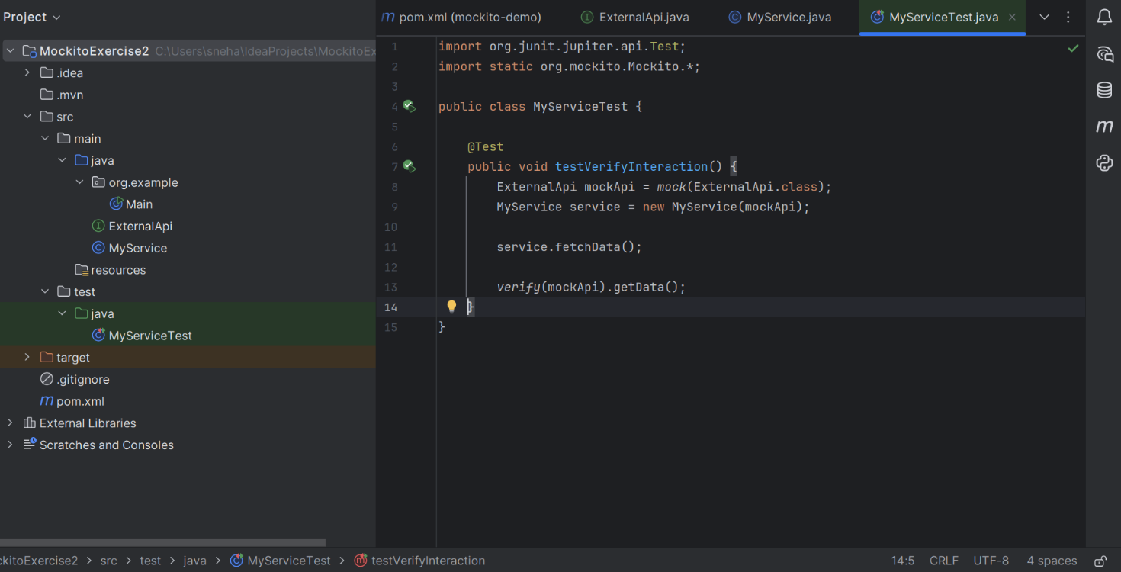

**OUTPUT:**

